Machine Learning for premature birth prediction during Pregnancy

¹ Hemalatha munnamgi, ²gudibandi poojitha, ³mallipam satya praneeth, ⁴thatikonda swathi
¹Sr.Assistant Professor, Department of Information Technology, Lakireddy Bali Reddy College of Engineering, Mylavaram, Andhra Pradesh-521230, India
^{2,3,4}Student, Department of Information Technology, Lakireddy Bali Reddy College of Engineering, Mylavaram, Andhra Pradesh-521230, India
¹lathamunnangi@gmail.com, ²gudibandipoojitha@gmail.com, ³mallipamedu@gmail.com ⁴ thatikondaswathi666@gmail.com
Abstract
Preterm or premature birth refers to the delivery of a baby before completing 37 weeks of gestation., poses significant health risks to newborns and remains a global concern. This paper addresses the need for an accurate predictive model for preterm birth using a comprehensive set of parameters from both laboratory and scan reports during pregnancy journey. Our study extends this scope to include a broader range of parameters. Our proposed system involves the integration of various lab and scan parameters, such as RBC count, WBC count, haemoglobin, TSH, abdominal circumference, cervix length, placenta position, etc...Unlike previous studies, which focus on a limited set of parameters, our research aims to build a machine learning model leveraging a diverse range of factors from lab and scan reports. The study includes the application of traditional statistical techniques like (Logistic Regression, Naïve Bayes) and ensemblling learners (Random Forest, Gradient Boost, XG Boost. Our end goal is to explore the association between various parameters and preterm labour, utilizing a dataset of approximately 4,000 patient records for lab reports and 7,000 patient records for scan reports. The predictive model is designed to assess the the likelihood of preterm birth occurring at the 35th week of gestation, allowing sufficient time for preventive measures. This research contributes to advancing our understanding of preterm birth predictors and facilitates timely intervention to reduce associated health complications and emotional burdens.
Keywords: Preterm Birth Prediction, Machine Learning, Laboratory and Scan Reports, Lab Report and Scan Parameters, traditional statistical techniques and ensembling Learners, Predictive Model, Patient Records, Preventive Measures, Neonatal Health, Healthcare Intervention, Global Preterm Birth Rates.
I Introduction
Premature birth, defined as delivery before completing 37 weeks of gestation, remains a critical global health concern due to its associated risks to neonatal health and increased rates of infant mortality. Our paper aims to address this challenge by applying machine learning techniques to predict preterm births during pregnancy. Unlike existing studies focusing on specific inflammation markers, our approach incorporates a comprehensive array of parameters from laboratory analyses and diagnostic imaging reports, expanding the scope of predictive features. Through traditional statistical techniques and ensemble learners such as logistic regression, naive bayes, random forest, and boosting algorithms, we seek to develop a robust predictive model capable of assessing the probability of preterm birth by the 35th week of gestation. Ultimately, our goal is to provide healthcare professionals and expectant mothers with a tool to mitigate critical risks for potential preterm patients, contributing to improved neonatal outcomes and a reduction in the global burden of preterm births.
II Literature Survey
In the exploration of predicting preterm birth during pregnancy and leveraging lab and scan parameters, this comprehensive literature survey amalgamates insights from various studies. One study delves into the role of inflammatory markers, particularly emphasizing the elevated neutrophil-to-lymphocyte ratio as a potential risk indicator for preterm birth ([1]). This underlines the importance of understanding the inflammatory processes associated with preterm labour. Another study introduces an innovative approach by developing an expert system that utilizes machine learning for preterm birth risk assessment, showcasing its superiority over traditional manual methods ([2]). This not only highlights the significance of incorporating advanced computational methods but also emphasizes the potential for personalized risk assessment in clinical settings. Serum markers take centre stage in a third study, focusing on the neutrophil-to-lymphocyte ratio as a potential predictor for late preterm birth, adding valuable dimensions to risk assessment ([3]). In a distinct context, a study situated in rural India introduces the Risk Prediction Conceptual Model (RPCM), a machine learning model that demonstrates promising accuracy in predicting preterm births using a combination of scan parameters and lab data, particularly with the SVM classifier ([4]). This reflects the importance of considering regional and demographic variations in developing effective prediction models. Shifting the focus to the broader context of inflammation, a study critically reviews its role in both preterm and term parturition, emphasizing the potential for early detection through a molecular signature of inflammation ([5]). Another study investigates blood cell subtypes, particularly neutrophils, as potential predictors for preterm labour. While revealing significant elevations, the study wisely advocates for further validation of these parameters before their clinical application ([6]). Lastly, a study contributes valuable insights into maternal leukocyte activation during both term and preterm labour, identifying an increase in monocyte and neutrophil activation. This study suggests the potential for novel diagnostic tools that could significantly advance the prediction of preterm birth ([7]). Collectively, these studies provide a nuanced and holistic understanding of preterm birth prediction, encompassing inflammatory markers, advanced computational methods, serum markers, regional considerations, and immune responses. These insights contribute to ongoing efforts to enhance the accuracy and effectiveness of predicting preterm birth during pregnancy, particularly when leveraging the wealth of data available through lab and scan parameters.
III Proposed Methodology
The proposed methodology for this research involves a comprehensive approach to preterm birth prediction, integrating machine learning algorithms with a diverse set of parameters obtained from lab tests and various scans conducted during pregnancy. Our study seeks to address the limitations of existing systems by expanding the scope of analyzed parameters and incorporating advanced machine learning techniques.
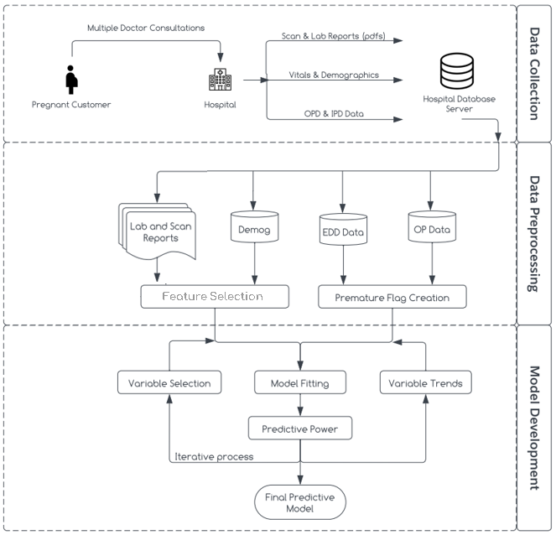
Fig 3.1 System Design
Data Collection:
For this study, data is collected from trusted repositories, comprising 4,332 patient records for laboratory reports and 7,114 patient records for scan reports. Each record is labeled to indicate whether the patient experienced preterm birth or not. The parameters derived from lab reports include RBC/WBC count, haemoglobin, TSH, and other relevant indicators, while scan reports contribute parameters such as abdominal circumference, placenta position, and more. Additionally, vital signs data, demographics, Estimated Due Date (EDD) data, Inpatient (IP) data, and Outpatient (OP) data are integrated into the model development process. Vitals provide critical physiological measurements, demographics offer insights into patient characteristics, and EDD data helps capture timing-related factors in pregnancy outcomes. IP data provides information on medical history and treatment, while OP data offers details on outpatient interventions relevant for predictive modeling. This comprehensive approach ensures the incorporation of diverse factors crucial for accurate preterm birth prediction.
Data Preprocessing:
Data preprocessing is a critical step in system design, involving the preparation of collected data for analysis and model development. Firstly, variable selection focuses on identifying relevant features to hone in on the most significant factors influencing outcomes. Analyzing variable trends provides insights into patterns and changes across different conditions or time periods. Extraction parameters involve deriving new variables from raw data to capture crucial information, while feature selection further refines variables using techniques like information gain. Finally, creating a premature flag involves generating an indicator variable to identify cases of prematurity based on specific criteria or thresholds related to gestational age or other pertinent factors. These steps collectively ensure that the data is appropriately refined and tailored for accurate analysis and modeling.
Model Development:
Model development is a pivotal stage in system design, where predictive models are crafted based on pre-processed data. Firstly, model fitting adjusts parameters to optimize performance, aiming to minimize errors or maximize data likelihood. Reports are generated to summarize findings, including model performance metrics and evaluation results. The final predictive model, refined through iterative processes, is developed to estimate preterm birth probability at the 35th week of gestation, utilizing parameters from both laboratory and scan reports aggregated at trimester levels. Evaluation involves rigorous testing on a separate validation dataset, using metrics such as accuracy, precision, recall, and AUC-ROC to assess predictive power and parameter significance. Ultimately, the model aims to provide healthcare professionals and expectant mothers with a practical tool for preventive measures.
3.1 Logistic Regression
Logistic Regression is a commonly used algorithm for binary classification tasks, such as predicting premature birth. In our study, we employed Logistic Regression to analyze the relationship between various laboratory and scan parameters and the likelihood of premature birth during pregnancy. By fitting a logistic regression model, we estimated the probability of premature birth based on input features and identified key predictors through feature selection and regularization techniques. The interpretability of logistic regression coefficients provided valuable insights into the direction and strength of each variable's influence, aiding in the identification of high-risk pregnancies and informing clinical decision-making.
3.2 Naïve Bayes
Naive Bayes is a probabilistic classification algorithm based on Bayes' theorem with an assumption of independence between predictors. Despite its simplistic assumptions, Naive Bayes has shown effectiveness in various applications, including medical diagnosis. In our study, we applied Naive Bayes to predict premature birth risk during pregnancy using laboratory and scan parameters as input features. By calculating conditional probabilities of premature birth given the observed parameter values, Naive Bayes provided a straightforward yet efficient way to classify pregnancies into high or low risk categories. Despite its simplicity, Naive Bayes demonstrated competitive performance in our experiments, highlighting its potential as a practical tool for early identification of pregnancies at risk of premature birth.
3.3 Random Forest
Random Forest is an ensemble learning algorithm that constructs multiple decision trees during training and outputs the mode of the classes (classification) or the mean prediction (regression) of the individual trees. In our study, Random Forest proved to be a robust algorithm for premature birth prediction by leveraging the strengths of multiple decision trees. By training a Random Forest model on our dataset consisting of laboratory and scan parameters, we were able to capture complex nonlinear relationships between predictors and the likelihood of premature birth. The ensemble nature of Random Forest helped mitigate overfitting and improved generalization performance, making it particularly suitable for handling high-dimensional data with potentially correlated features. Moreover, the algorithm provided insights into feature importance, aiding in the identification of critical predictors contributing to premature birth risk.
3.4 XG Boost
XG Boost, an implementation of gradient boosted decision trees, has gained popularity for its exceptional performance in various machine learning tasks, including classification and regression. In our paper, we utilized XG Boost to predict premature birth risk during pregnancy based on a set of laboratory and scan parameters. By iteratively adding decision trees that minimize a specified loss function, XG Boost effectively learned complex patterns in the data, leading to superior predictive accuracy compared to traditional algorithms. The algorithm's ability to handle missing values, categorical variables, and nonlinear relationships proved advantageous in our study, allowing us to extract valuable insights from heterogeneous pregnancy data. Additionally, XG Boost provided interpretable feature importance scores, facilitating the identification of key predictors associated with premature birth risk.
3.5 Stacked Ensemble (Logistic Regression + Random Forest + Gradient Boosting)
Our study introduces a novel approach to premature birth prediction during pregnancy through the implementation of a stacked ensemble model. By combining the strengths of Logistic Regression, Random Forest, and Gradient Boosting, we aimed to harness the diverse learning capabilities of these algorithms to improve predictive performance. The stacked ensemble model operates by aggregating predictions from multiple base models, leveraging the complementary strengths of each algorithm to enhance overall accuracy and robustness. Logistic Regression offers interpretability and captures linear relationships between predictors and premature birth risk, while Random Forest excels at capturing complex nonlinear patterns in the data and mitigating overfitting. Meanwhile, Gradient Boosting iteratively improves prediction accuracy by focusing on the residual errors of previous models, thereby refining the ensemble's predictive power. Through careful model stacking and blending of predictions, our stacked ensemble model synergistically integrates the predictive abilities of these diverse algorithms, resulting in a more accurate and reliable predictor of premature birth risk during pregnancy. Furthermore, the ensemble nature of the model helps mitigate individual algorithm biases and variance, leading to improved generalization performance on unseen data. Experimental results demonstrate the superior predictive performance of the stacked ensemble model compared to individual algorithms, highlighting its potential as a valuable tool for early identification of high-risk pregnancies and informed clinical decision-making.
3.6 Integrated Analysis
The proposed methodology for predicting premature birth during pregnancy involves an integrated analysis of three distinct approaches: lab parameters, scan parameters, and a combined approach utilizing both data sources. Initially, machine learning algorithms were applied separately to lab parameters, focusing on biochemical markers and physiological measurements. This aimed to assess the predictive power of these indicators in isolation. A similar analysis was conducted using scan parameters, emphasizing ultrasound imaging data to evaluate its contribution to premature birth prediction. Subsequently, a holistic approach combining lab and scan parameters was adopted to leverage the complementary nature of biochemical and imaging markers. By systematically comparing algorithm performance across these approaches, insights were gained into the relative importance of different feature sets and their impact on predictive modeling outcomes. Overall, this integrated analysis framework not only expanded understanding of predictive factors for premature birth but also facilitated the development of more effective risk assessment models tailored to individual patient profiles.
3.7 Information Gain
In our study, we employed feature selection techniques to identify the most informative predictors for premature birth prediction. Information gain, a commonly used metric in feature selection, measures the reduction in entropy or uncertainty achieved by splitting data based on a particular feature. Features with higher information gain values are considered more informative and are thus prioritized for inclusion in predictive models. Through rigorous analysis, we identified a subset of features with high information gain values, indicating their significance in predicting premature births. These features provide valuable insights into the underlying factors contributing to preterm delivery and enable more accurate risk assessment. The selection of features based on information gain enhances the interpretability and efficiency of predictive models, as it focuses on the most relevant predictors while discarding redundant or less informative features. By leveraging the power of information gain, we can develop more robust and accurate predictive models for premature birth prediction, ultimately improving maternal and infant healthcare outcomes.
IV Results & Discussions
Our study aimed to assess the predictive performance of various machine learning algorithms for a model focused on premature birth prediction using only lab parameters. In this section, we present the results of our analysis, which include the accuracy metrics obtained for each algorithm evaluated. By comparing the performance of different algorithms, we aimed to identify the most effective predictive models for early detection of premature births based solely on laboratory data. The findings presented here offer valuable insights into the strengths and limitations of each algorithm, guiding future research and clinical applications in maternal and infant healthcare.
4.1 Lab Parameters
Our study focused on evaluating the predictive performance of various machine learning algorithms for a model based solely on lab parameters. In this section, we present the results of our analysis, which include the accuracy metrics obtained for each algorithm evaluated. By comparing the performance of different algorithms within the context of lab parameters, we aimed to identify the most effective predictive models for early detection of premature births.
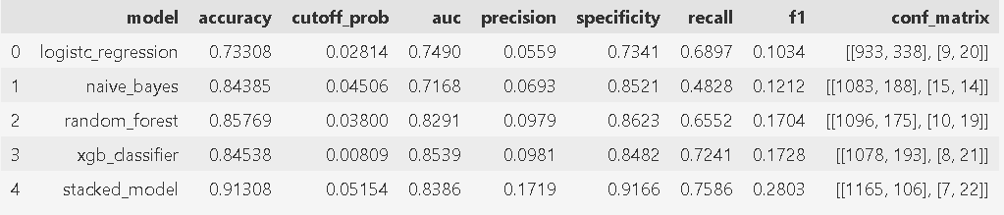
Fig 4.1.1 Performance Metrics using lab parameters
Above table gives the predictive performance of various machine learning algorithms for a model focused on premature birth prediction using a combination of lab parameters and imaging scan data. Among the algorithms assessed, the Stacked Model demonstrated the highest accuracy with a score of 0.91308, indicating superior predictive performance. Notably, Random Forest also exhibited strong performance with an accuracy of 0.85769, closely followed by Naive Bayes with a score of 0.84385. However, Logistic Regression and XG Boost achieved comparatively lower accuracies of 0.73308 and 0.84538, respectively. These findings highlight significant variations in predictive capability among the algorithms tested, underscoring the importance of algorithm selection in optimizing predictive performance for premature birth prediction.
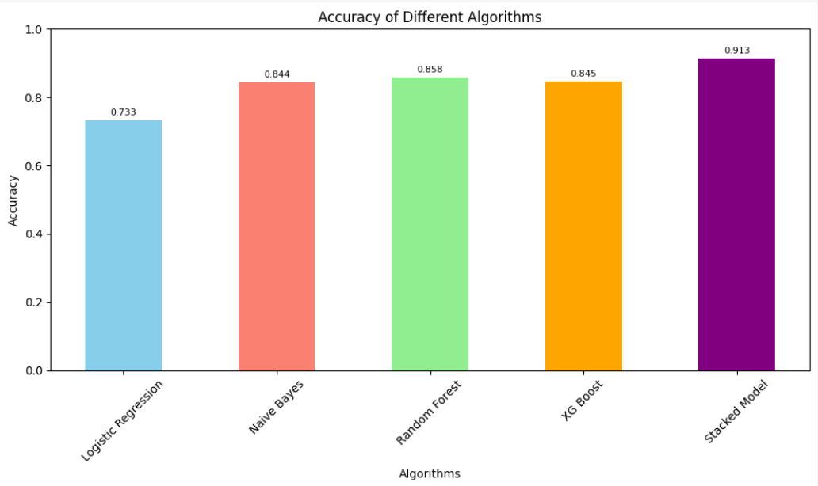
Fig 4.1.2 Accuracies of various algorithms using lab parameters
4.2 Scan Parameters
Our study focused on evaluating the predictive performance of various machine learning algorithms for a model based solely on scan parameters. In this section, we present the results of our analysis, which include the accuracy metrics obtained for each algorithm evaluated. By comparing the performance of different algorithms within the context of scan parameters, we aimed to identify the most effective predictive models for early detection of premature births.
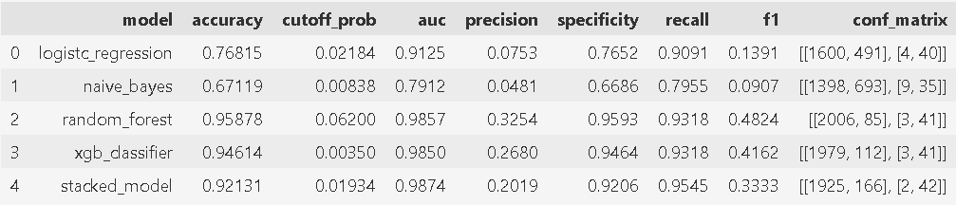
Fig 4.2.1 Performance Metrics using scan parameters
Our study aimed to assess the predictive performance of various machine learning algorithms for a model focused on premature birth prediction using lab parameters exclusively. The accuracy metrics obtained for each algorithm are summarized in Fig 4.2.1. Notable variations were observed in the predictive performance of the algorithms, with Random Forest achieving the highest accuracy of 0.95878, closely followed by XG Boost with 0.94614. These algorithms demonstrated strong predictive capabilities, indicating their potential utility in identifying premature births based on lab parameters alone. In contrast, Logistic Regression and Naive Bayes exhibited lower accuracies of 0.76815 and 0.67119, respectively. Despite not achieving the highest accuracy, the Stacked Model displayed competitive performance with an accuracy of 0.92131. These findings underscore the importance of algorithm selection in optimizing predictive accuracy for premature birth prediction. Random Forest and XG Boost emerge as promising candidates, offering superior performance compared to Logistic Regression and Naive Bayes. However, further investigation is warranted to explore the potential synergies of ensemble methods, such as the Stacked Model, in enhancing predictive accuracy.
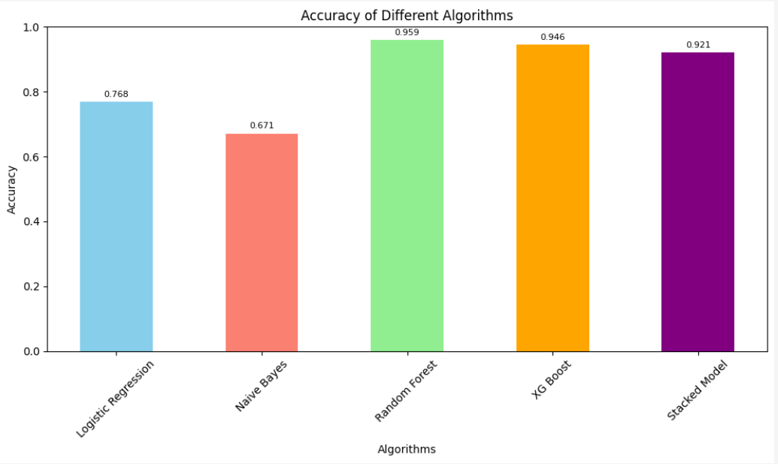
Fig 4.2.2 Accuracies of various algorithms using scan parameters
4.3 Lab & Scan Parameters
Our study focused on evaluating the predictive performance of various machine learning algorithms for a model based on lab and scan parameters. In this section, we present the results of our analysis, which include the accuracy metrics obtained for each algorithm evaluated. By comparing the performance of different algorithms within the context of lab and scan parameters, we aimed to identify the most effective predictive models for early detection of premature births.
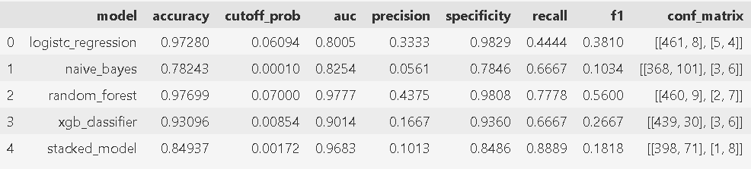
Fig 4.3.1 Performance Metrics using lab and scan parameters
In our analysis of classification models, Logistic Regression emerges as the top performer with an accuracy of 97.28%, highlighting its simplicity and effectiveness. Random Forest closely follows with an accuracy of 97.70%, showcasing the power of ensemble learning methods. XG Boost achieves an accuracy of 93.10%, demonstrating its ability to optimize predictive accuracy through gradient boosting techniques. Naive Bayes lags behind with an accuracy of 78.24%, suggesting potential challenges in capturing complex relationships within the data. The Stacked Model integrates predictions from multiple base models, achieving an accuracy of 84.94%, indicating room for improvement through further refinement of model combinations and parameters.
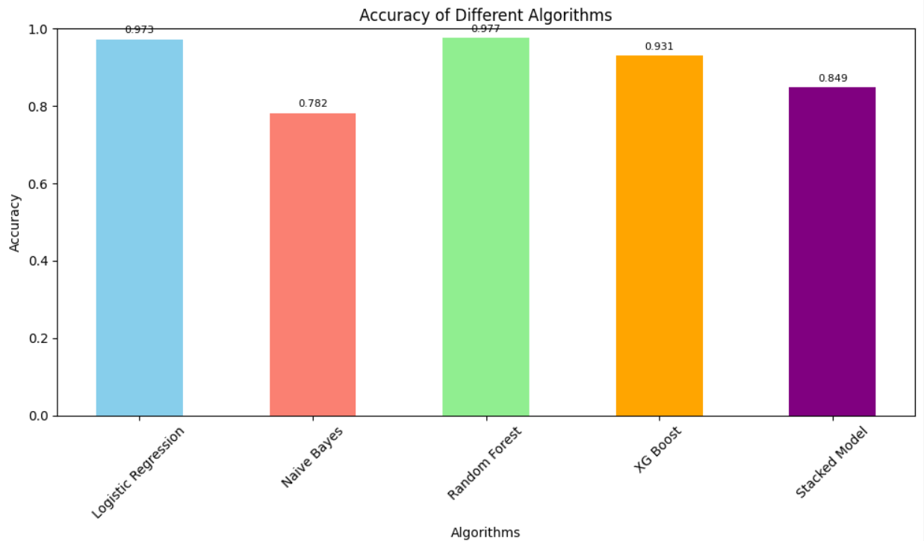
Fig 4.3.2 Accuracies of various algorithms using lab & scan parameters
V Conclusion
Our study represents a comprehensive exploration of machine learning-based approaches for predicting premature births during pregnancy. By leveraging both laboratory and scan parameters, we have demonstrated the potential of predictive modelling in identifying pregnancies at risk of preterm delivery. The findings of our study highlight the importance of algorithm selection and feature consideration in optimizing predictive performance. Through our analysis, we have identified several key factors that play a crucial role in assessing the risk of preterm births. These insights offer valuable guidance for clinicians and researchers in developing targeted interventions and personalized management strategies to mitigate the risk of premature delivery. Moving forward, further research is needed to validate the findings of our study and enhance the robustness of predictive models in clinical practice. Prospective studies involving larger cohorts and diverse populations will help to corroborate our results and ensure the generalizability of predictive models across different settings. Our study underscores the potential of machine learning techniques in advancing our understanding of premature birth prediction and improving maternal and infant healthcare outcomes. By harnessing the power of predictive modelling, we can pave the way for early identification and intervention, ultimately reducing the burden of preterm birth complications on families and healthcare systems.
VI FUTURE SCOPE
Our study lays the groundwork for several avenues of future research and development in the field of premature birth prediction using machine learning techniques.
Expansion of Data Collection Efforts: Given the observed trend towards acute preterm births attributed to factors such as dietary changes, environmental pollution, and shifting living standards, future efforts should prioritize the collection of more comprehensive datasets encompassing these variables so that model can predict at the end of 30th week. This entails collaborating with public health agencies, research institutions, and healthcare providers to gather diverse and extensive data sets that capture the multifaceted influences contributing to preterm birth risk. Additionally, leveraging advanced data analytics techniques, including data fusion and integration, can enhance the richness and granularity of the dataset, enabling more robust predictive modelling.
Integration of Comprehensive Patient History: Incorporating detailed patient histories, including disease records and previous pregnancy outcomes, into the predictive model represents a critical avenue for enhancing its predictive power. By leveraging this information, the model can better capture individual-level risk factors and tailor predictions to the unique characteristics and medical history of each patient. Collaborations with healthcare providers and electronic health record systems can facilitate seamless integration of these data sources, ensuring that the predictive model is informed by a holistic understanding of the patient's health trajectory. Additionally, ongoing validation and refinement of the model based on real-world patient data will be essential to optimize its performance and clinical utility.
REFERENCES
[1] N. Saranya, R. Pavithra, M. Priya, “Prediction of Preterm Baby using Machine Learning Algorithm,” IOSR Journal of Nursing and Health Science (IOSR-JNHS), Volume-8, Issue-2, 2019, PP-85-90.
[2] T. Cobo, M. Kacerovsky, B. Jacobsson, “Risk for spontaneous preterm delivery,” Volume-150, Issue-1, 2020, PP-17-23
[3] B. Ahadi, Hamid A. Majd, S. Khodakarim, F. Rahimi, N. Kariman, M. Khalili, N. Safavi, “Using support vector machines in predicting and classifying factors affecting pre-term delivery,” Archives Of Advances In Biosciences(Journal Of Paramedical Sciences), 2016, Volume-7, PP-37-42.
[4] T. Tran, Wei Luo, D. Phung, J. Morris, K. Rickard, S. Venkatesh, “Pre-term Birth Prediction: Deriving Stable and Interpretable Rules from High Dimensional Data∗”. Proceedings of the 1st Machine Learning for Healthcare Conference, PMLR 56:164-177, 2016.
[5] N. S Prema, M. P Pushpalatha, “Machine Learning Approach for Preterm Birth Prediction Based on Maternal Chronic Conditions”. Emerging Research In Electronics, Computer Science and Technology, Volume-545, PP-581-588, 2019.
[6] Z. Asli, A. Seval Ozgu-Erdinc, “Prediction of Pre-term Birth: Maternal Characteristics, Ultrasounds Markers, and Biomarkers: An Updated Overview,” Article ID 8367571, Volume 2018, 2018.
[7] J. L. Wallace, K. L. Aland, K. Blatt, E. Moore, and E. A. DeFranco, “Modifying the risk of recurrent pre-term birth: influence of trimester-specific changes in smoking behaviors,” American Journal of Obstetrics & Gynecology, vol. 216, no. 3, pp. 310–310.e8, 2017.

